

*You are cordially invited to participate in a*

*two-webinar series focusing on*

**COUNSELING CLIENTS ON HOW TO SET UP A NONPROFIT**

**September 25, 10:00—12:00 EDT**: Legal Aspects of Forming a Nonprofit

Conducted by: Marty Sweterlitsch, Partner

Benesch, Friedlander, Coplan & Aronoff LLP

**October 3, 10:00—11:00 EDT**: Business Issues to Consider when Starting a Nonprofit

Conducted by: Jennifer S. Eschbach, Executive Director

Ohio Association of Nonprofit Organizations

**To register, CTRL + CLICK to follow link:**

<http://development.ohio.gov/CBAWebinarRSVP/>

**Cost:** **FREE** for all CBA Network Members, SBDC Directors, Counselors, and SBDC Clients

**LEARNING OBJECTIVES:**

The participants should be able to demonstrate a basic understanding of the following:

Part I: (Legal Aspects of Forming a Nonprofit) Objective: Attendees will learn the basic requirements for starting and maintaining a not for profit tax exempt organization including entity creation and federal tax exemption standards.

Part II (Business Issues to Consider when Starting a Nonprofit) Objective: Attendees will learn:

* The nonprofit landscape (the number of nonprofits in Ohio, where the revenue comes from)
* Creating a board (the kind of folks you should have on your board)

**SPEAKERS:**



Ms. Sweterlitsch is a partner with the firm's Health Care Practice Group. Her practice focuses on not-for-profit, administrative, health, state tax, and federal and state tax exemption law and lobbying. Significant areas of practice include creation, reorganization, mergers and consolidations and ongoing advice to not-for-profit corporations, state and federal tax and tax exemption for not-for-profit organizations, and legal issues related to charitable solicitation and fundraising. She also has experience as borrower's counsel for not-for-profit entities doing tax exempt financing.

She has been involved over many years with legislative initiatives affecting the regulation, operation and taxation of not-for-profit entities, including changes to the charitable solicitation laws. She represented the interests of Ohio Association of Nonprofit Organizations and its member organizations in negotiations over the public funds contracting and accountability legislation.

She serves as general counsel for the Ohio Water Development Authority, Leading Age Ohio and numerous not-for-profit tax exempt organizations including several trade associations. She also serves as legislative counsel for the Ohio Alliance of YMCA’s, the Ohio Association of Child Care Providers and several other non- profit organizations. She is a graduate of The Ohio State University, Moritz College of Law.

Ms. Sweterlitsch has authorednumerous newsletterarticles targeted to those in the nonprofit sector, an**d** has received multiple awards including the 2013 Alvis House Founders Award, Listed in Best Lawyers in America 2013, and an honoree of Ohio United Way’s “100 Years—100 Heroes” 2013.

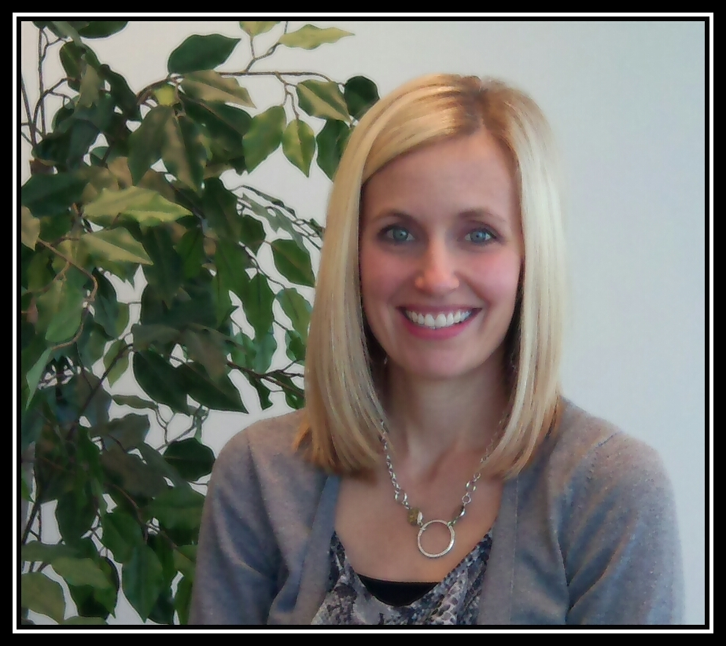

Jennifer Eschbach is the executive director for the Ohio Association of Nonprofit Organizations (OANO), a statewide membership association of more than 500 nonprofit organizations. The mission of OANO is to provide leadership, education and advocacy to enhance the ability of Ohio’s nonprofit organizations to serve their communities.

Ms. Eschbach joined OANO in 2004 as the organization’s director of membership & marketing.

After serving seven years in this position, Ms. Eschbach was appointed executive director in 2012. As the executive director, she oversees the more than 50 regional educational programs and training events that OANO hosts each year, including a statewide legislative day and annual conference for nonprofits.

She monitors public policy issues that affect Ohio’s nonprofit organizations and manages the Standards for Excellence program, an ethics and accountability code for Ohio’s nonprofit sector.

Prior to joining OANO, Ms. Eschbach was an anchor/reporter for various news outlets throughout the state of Ohio.

Ms. Eschbach received her undergraduate degree in Journalism from The Ohio State University. She is a member of the board of directors and planning committees for several Central Ohio nonprofit organizations.